**We Must Consider Manual Bag-Valve Ventilation**

**as a Potential Life Saving Option for COVID-19!**

**Sunday, March 22**

Send correspondence to airbaginitiative@gmail.com

Initial Report compiled by Elizabeth Bailey (B.S. Mathematics; PhD Candidate, Planetary Science), Alex O’Donnell (B.S., Mechanical Engineering).

**NOTICE \*\*\*\*\*\*\*\*\*\*\*\*\*\*\*\*\*\*\*\*\*\*\*\*\*\*\*\*\*\*\*\*\*\*\*\*\*\*\*\*\*\*\*\*\*\*\*\*\*\*\*\*\*\*\*\*\*\*\*\***

**\*\*\*\*\*\*\*\*\*\*\*\*\*\*\*\*\*\*\*\*\*\*\*\*\*\*\*\*\*\*\*\*\*\*\*\*\*\*\*\*\*\*\*\*\*\*\*\*\*\*\*\*\*\*\*\*\*\*\*\*\*\*\*\*\*\*\*\*\*\*\*\***

**Neither author of this document has a formal background in bioethics or medicine, and we must leave these decisions to those who do. We apologize if any of our suggestions on this ethically delicate topic risk putting any person unnecessarily in harm’s way, more than they already would be during this extreme crisis.**

**\*\*\*\*\*\*\*\*\*\*\*\*\*\*\*\*\*\*\*\*\*\*\*\*\*\*\*\*\*\*\*\*\*\*\*\*\*\*\*\*\*\*\*\*\*\*\*\*\*\*\*\*\*\*\*\*\*\*\*\*\*\*\*\*\*\*\*\*\*\*\*\*\*\*\*\*\*\*\*\*\*\*\*\*\*\*\*\*\*\*\*\*\*\*\*\*\*\*\*\*\*\*\*\*\*\*\*\*\*\*\*\*\*\*\*\*\*\*\*\*\*\*\*\*\*\*\*\*\*\*\*\*\*\*\*\*\*\*\*\*\*\*\*\***

**Introduction**

In addition to personal protective equipment (PPE), today, ventilators are a major limiting factor in saving lives from COVID-19. Typically, a ventilator is a complex machine with numerous functions. These functions optimize their safety and efficacy. However, while these numerous functions are important, it is also important to remember that the basic purpose of a ventilator is simply to help patients pass oxygenated air over their pulmonary membranes, to bring them out of respiratory failure. While the functions of modern ventilators are certainly preferable to have if possible, *this basic function— of improving gas exchange in the lungs—does not inherently depend on having a complicated machine.*

It is evidently hopeless to manufacture enough modern ventilator machines to combat this rapidly escalating crisis. Therefore, we must step back, and consider the basic purpose of a ventilator. We must ask: what is the ***simplest possible*** ventilator that would be more likely to save than kill? What is the ***quickest possible*** way to produce as many as possible? And, crucially, **could this rudimentary ventilator actually help?**

In our zest for ingenuity, it is critical to remember that *every* mechanical part, no matter how innovative, adds additional, deadly time to development and fabrication.

Currently, the simplest form of ventilator is known as a *bag valve* (aka Ambu bag, manual resuscitator, self-inflating bag) (Figure 1), and its operation is *completely manual*—as in, carried out by a human operator. **This use of human operation removes the need to produce complex machinery to govern the operation of the device.** The bag valve system consists of a self-inflating “bag” that is repeatedly squeezed by the human operator’s hand to induce ventilation, a reservoir bag for supplemental oxygen, and two valve systems. It is connected to the patient’s airways ideally by a tracheostomy tube (which must be done by a medical professional), or, alternatively, a face mask (which carries numerous risks and likely severe complications, as outlined below). Bag valve ventilators are commonly used by medical professionals in times of crisis (such as now), or to sustain respiratory support while transferring a patient between ventilator machines.

**The humble bag valve ventilator, where tracheostomy can be performed, has already proven itself as a lifesaver in times of crisis not unlike this one.** As a prime example, in the 1952 Copenhagen polio epidemic, in response to the shortage of ventilator machines, 200 medical students—followed by a number of dental students—were called upon to provide manual ventilation to patients using rubber bags attached to tracheostomy tubes, a “heroic solution” which is estimated to have dropped the mortality rate from ~90% to ~25% (West, 2005).

We must note, importantly, that the nature of COVID-19 is inherently different than polio, and worse odds are very likely—as it involves a severe lung infection rather than paralysis as in the case of polio. At the same time, given that patients are being denied life saving care, we must consider the potential use of this device, and organize ourselves accordingly.

This document is organized as follows:

I. Overview of pros and cons.

II. Possible ways to mitigate cons.

III. Production methods.

IV. Closing remarks and outline of needed resources.

**Moreover, the original authors of this document are a scientist and engineer—not trained medical experts—and request all available constructive input from those who have actual expertise in this topic.**

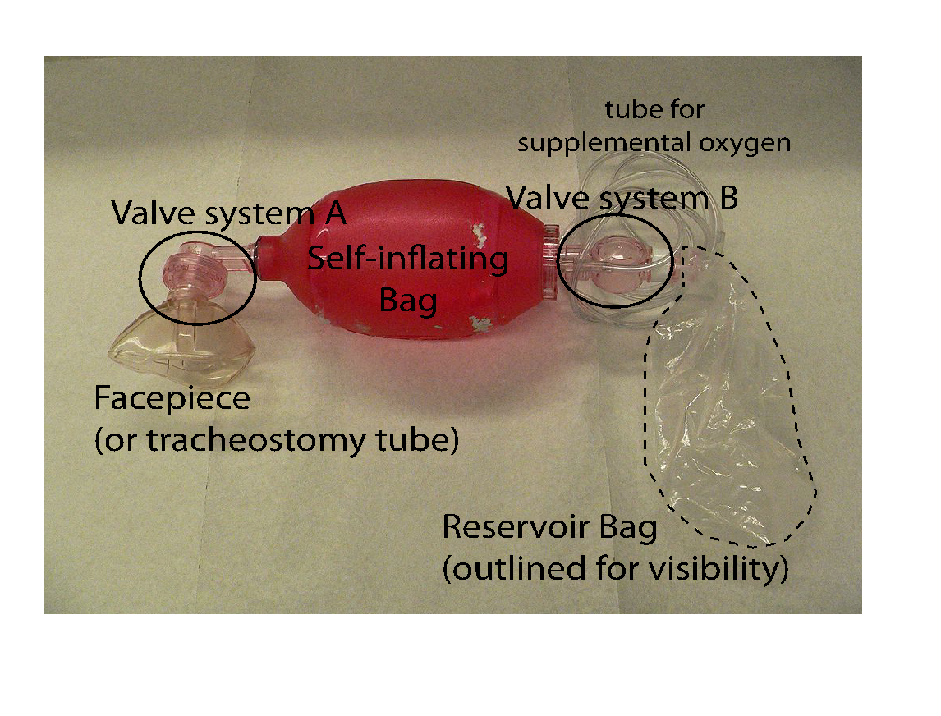

**Figure 1: Bag valve mask. Fabrication of these parts, and their details, is discussed in Section III. (Photo credit: Wikipedia.)**

I. Overview of pros and cons.

Listed below are some major pros and cons of using bag valve masks to combat this epidemic.

**Pros of bag valve masks:**

* Simplest possible existing respirator design, currently already in widespread use. Commonly used in emergency rooms, crash carts, etc.
* While tracheostomy is vastly preferable to using a facemask due to numerous issues associated with facemasks, once tracheostomy is completed by a trained professional, the *respirator itself* can potentially be used, from start to finish, by somebody with a level of training similar in scope to CPR training.[1] (see for example: <https://www.youtube.com/watch?v=1goz1l28kUQ>) Training could be done via distributed video, for efficiency.
* While room for grave error clearly exists, particularly if the device is used in a reckless or improper fashion, the training necessary to operate the ventilator itself with a reasonable degree of safety appears to be potentially relatively simple (albeit depending on disease progression and the possible need, unfortunately, for restraint of the patient). In principle, it appears that nearly any adult could operate the respirator, or even a child/adolescent who is old enough to have a reasonable understanding of what to do. Obviously, this is a horrifying scenario to be discussing, **but many people around the world would prefer any option possible to keep their loved ones alive right now.**
* Historic precedent exists for the successful use of bag valves in times of crisis such as this, albeit for a different disease—notably, the 1952 Copenhagen polio epidemic, as discussed above.

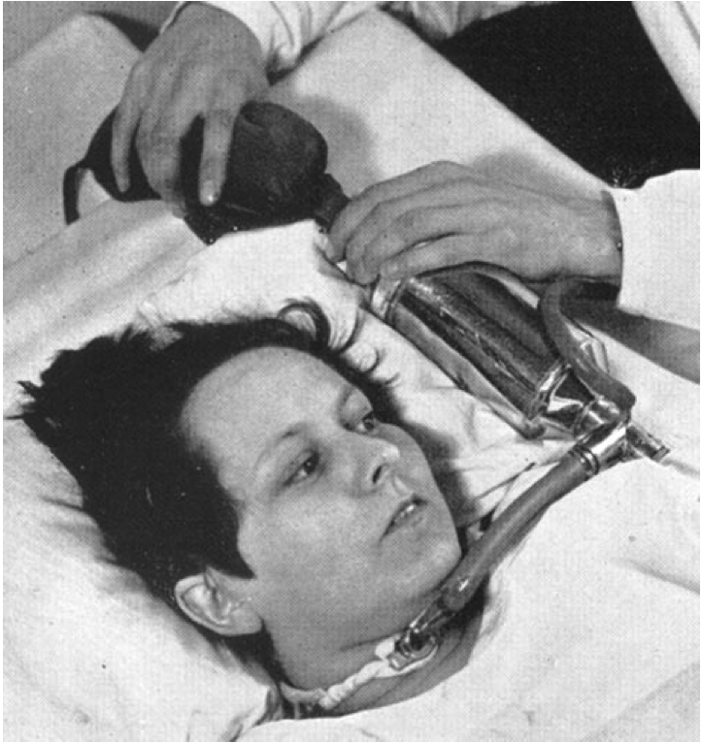

**Cons of bag valve masks:**

* **Requires humans** to gently squeeze a bulb repeatedly, 24/7, at a reasonable breathing rate, until the patient recovers, for weeks or months—a heroic effort. At least two people would be necessary to save each patient with this device, taking challenging and tedious shifts, and potentially risking exposure to the virus, if this risk is not properly mitigated. As discussed in the next sections, this issue could be mitigated by organizing a corps of human manual ventilators—potentially either volunteers who have acquired immunity to the disease, or using an *appropriate* means of positive-pressure containment, constructed efficiently but with no sacrifices made in terms of safety. This idea is further discussed in the next sections.
* Device carries a potential risk of aerosolizing the virus more than would happen with other types of respirator, posing additional possible risk to medical providers (if used in a hospital), or to nearby residents (if used in a domestic setting). This may be mitigated by concentration of ventilated patients in places away from the rest of society—such as large sport stadiums, as further discussed below.
* Risk of injury to patient:
  + Overinflation of the lungs, causing injury (potentially severe), is a common issue with this type of ventilator.
  + Hyperventilation of the patient is also a common mistake, but can be prevented with care and effective training.
  + If tracheostomy is not available, respiration through a face mask carries many risks of severe injury: aspirating stomach contents, inflating the stomach instead of the lungs, or otherwise causing an assortment of major bodily harm.

II. Mitigation of Cons

i. Need for Human operators.

A primary strength of the bag valve respirator is simplicity and ease of fabrication. With this strength comes a drawback: it requires a heroic degree of simple human labor (2 people per patient to operate 24/7 in shifts, for a timespan of weeks), and the safety of these volunteers must be ensured.

One obvious potential solution is for the ventilators to possibly be operated by those with acquired immunity who have recently recovered from the virus. However, the nature of immunity to COVID-19 is not yet known. Similar to chicken pox or many other viruses, it is highly possible that initial immunity is temporary and eventually wears off over a span of years. Overall, it seems it would be surprising from the standpoint of virology and immunology, for recovered COVID-19 patients to lack immunity in the subsequent months after recovery. The current general expectation among medical experts, based on existing coronaviruses, is that recovered patients will experience an immune response lasting at least a few months, but quite probably not more than a year. (Greenfieldboyce)

Limited evidence does demonstrate immunity for COVID-19. Thevarajan et al (2020) have studied the kinetics of immune responses in a case study of one 47-year-old female patient in Wuhan, and found SARS-CoV-2-specific immunological changes for 7 days after symptoms were resolved. In a review by Channappanavar, Zhao, and Perlman (2015) on respiratory coronaviruses, it is stated:

“Follow up studies from patients who recovered from SARS suggest that the SARS-CoVj-specific antibody response is short lived. In these patients, SARS-CoV-specific IgM and IgA response lasted less than 6 months, while virus-specific IgG titer peaked four-months post infection and markedly declined after one year. Despite the lack of virus-specific memory B cell response, SARS-CoV-specific memory T cells persist in SARS recovered patients for up to 6 years post-infection.”

This seems to indicate that for COVID-19—if it is similar to SARS, which is not yet known—it may be that ideal immunity might be expected to last several months, with residual longer-lasting immunity. **We do not currently know,** but we should note that it is probable that a period of immunity exists after recovery from COVID-19. This immunity might potentially offer an ethically adequate safety net for immune human operators who have recovered from the virus to experience further exposure to the virus in this proposed makeshift healthcare setting. **In the effort to fight COVID-19, it is of primary urgency that we determine the nature and duration of immunity in recovered patients, for adequately immune individuals will quite possibly have the superpowers that help us save as many lives as possible, whether through manual respiration or other means.**

To re-emphasize, it is absolutely crucial, particularly from an ethical standpoint, to determine whether immunity is expected, and the expected time-frame of immunity, in the most expedited manner possible that still allows for reasonable safety and appropriate ethics. We may be able to deduce the properties of immunity by watching the examples of China and Italy. It may also be ethically possible to positively deduce immunity by monitoring antibodies in volunteers who have recovered from the disease. In that case, there would be a **critical need for widespread, rapid assessment of the continued presence of antibodies in human operators.**

In case the bag valve respirator is determined to be a viable lifesaving means, then to be of much help, due to the time-sensitive nature of this issue, it is necessary we begin **now—or rather, yesterday—**to recruit **potential volunteers**—perhaps as they exit the hospital or during a quarantine follow-up. Of course, the safety and ethical considerations must still be worked out, and we may ultimately determine that bag valve masks are not actually a viable and ethically sound lifesaving means for COVID-19. **An inevitable ventilator shortage is already underway in the United States and elsewhere. We must act correctly but rapidly to save lives, and think several steps ahead from where we are now. If we wait until we know this protocol would help, it will be too late. Let us therefore consider recruiting a *potential* volunteer bag-squeezing corps now rather than later. For this type of simple ventilator, *human volunteers*, rather than manufacture of equipment, would likely be the ultimate limiting factor for deployment.**

Due to the exponential nature of unchecked transmission, we cannot necessarily expect there to be enough immune volunteers for this plan to save as many people as desired. If a reliable and safe means can be produced which ensures, beyond a shadow of a doubt, that volunteers and patients do not share any air, it is potentially possible that volunteers without immunity could serve. This could include hazmat suits to house the volunteers, or glove boxes to house the patients. Positive pressure and a reliable alarm system would be non-negotiable.

**Additionally, countries whose outbreaks have run their course may be able to contribute immune volunteers to this effort in other countries. However, it would also be important to ensure nobody benefits from the human rights violation of another country (such as China), and that “volunteers” are in no way being forced or wrongly compelled to put themselves in harm’s way.**

ii. Aerosolization risk.

Another risk lies in the possibility that the use of this apparatus will increase aerosolization of the virus to a significant degree compared to modern ventilator machines, endangering healthcare workers. Especially with PPE currently in short supply, it is critical that we ensure our medical professionals are not endangered more than their job already requires.

One possible solution would be to house the patients in sealed glove boxes or similar chambers with glove access (not necessarily a box), with adequate pressure differential to protect human operators and medical staff, as mentioned in the preceding section. Another solution would be to house this operation in isolated treatment centers, such as stadiums, following the strategic precedent of China. This possibility is illustrated in Figure 3.

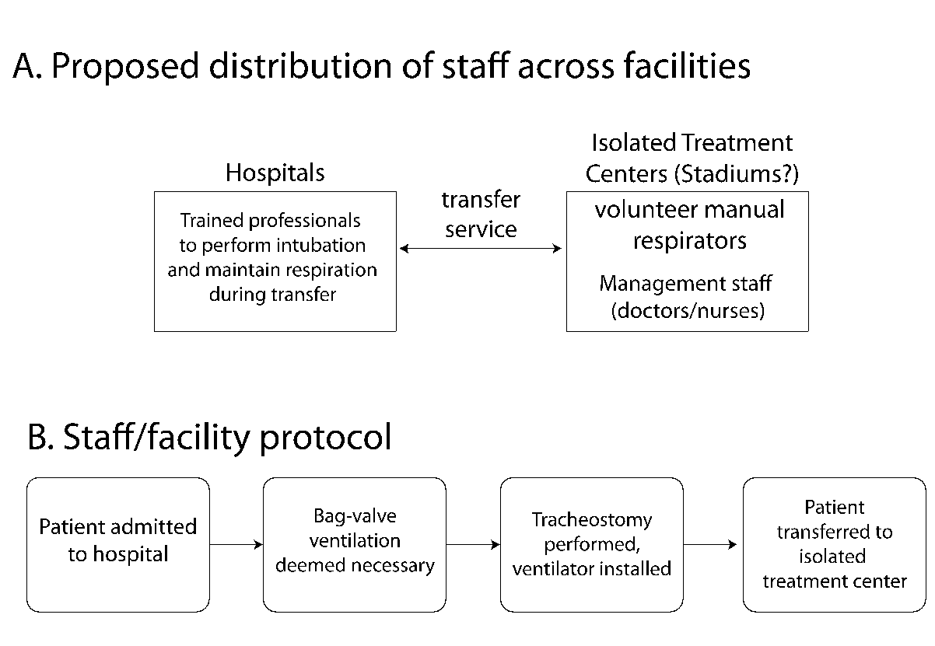

iii. Injury risk to patient.

The risk of injury to the patient is an obvious factor in determining whether bag-valve ventilation is an appropriate lifesaving means. On one hand, bag-valve ventilation—even with a face mask rather than a tracheostomy tube, which incurs more danger—is safe enough to be commonly used in routine anesthesia. At the same time, the possible use of non-medical-professional volunteers to carry out this inherently simple task for an extended period of time carries some obvious degree of risk, as does the lack of precise control of the tidal volume (amount of air squeezed into lungs). Some possible mitigating steps for the most widely-mentioned risks of this type of ventilator, are listed below:

***Risk of overinflation/barotrauma:*** These respirators inherently lack tidal volume control, as the volume of delivered air depends entirely on the amount that the operator squeezes the bag. Therefore, these respirators pose an inherent risk of overinflation. This risk is evidently not so severe in common practice to preclude the common use of these ventilators in times of necessity or crisis. However, the safety of long-term use, particularly with civilian operators, and with the particular issues accompanying this disease, is not clear, and must be determined. It is critical that the potential training video be as clear as possible in describing these risks, and how to prevent them. Moreover, while the risk of barotrauma is normally reasonably low to justify the use of these ventilators in common practice, the risk of barotrauma in the context of treating this specific disease, in which the lungs are diseased, is something that must be considered in deciding whether bag-valves present a viable lifesaving means for COVID-19 patients.

***Risk of hyperventilation:*** Hyperventilation, in which breathing is done too rapidly by the operator, can be a concern. It would be a natural tendency for an operator to squeeze the bulb more rapidly than necessary, especially if they have seen a dramatized depiction of emergency bagging in a fictional TV show or movie. There is reason to hope that this could be mitigated with an appropriate training video describing techniques to avoid this. For example, operators could be instructed to squeeze the bag at a rate in accordance with their own breathing.

***Risks associated with long-term use of face masks:*** In some settings, particularly in developing countries or where resources are otherwise overwhelmed, safe tracheostomy may not be available, at least not immediately. In principle, a face mask could then be used that seals over the patient’s nose and mouth. This common configuration of the bag-valve ventilator, commonly known as a bag-valve-*mask*, is a regular staple in emergency medical kits. However, the use of a mask instead of a tracheostomy carries numerous inherent risks, possibly severe. This is because air (possibly the majority of air) can be forced into the GI tract rather than the lungs, leading to inefficient respiration, trauma, air embolism, or all manner of assorted severe issues**. While a face mask poses a simpler solution than intubation, long-term use of a face mask rather than intubation is likely to carry lasting consequences for the patient that are so severe, that *long-term* ventilation with only a face mask might not be warranted.[2]** It is up to doctors to determine this, but tracheostomy would likely be a vastly preferable means of long-term manual ventilator support. Patients could potentially be bagged with a mask for a short period while they await tracheostomy, or perhaps bagged with a mask as a last resort. **It is up to the medical professionals to determine what specific action is warranted, weighing the risks associated with face masks versus intubation, and the overall risks of injury versus life saving capabilities of this device.**

III. Details of Parts and Production Methods

A self-inflating bag valve ventilator consists of a mouthpiece, patient and pressure limiting valves (“valve system A” ; Fig 1&4), bag, and reservoir bag with additional “valve system B”. Please refer to Figure 4 for a listing of the various components on this type of mask (1).

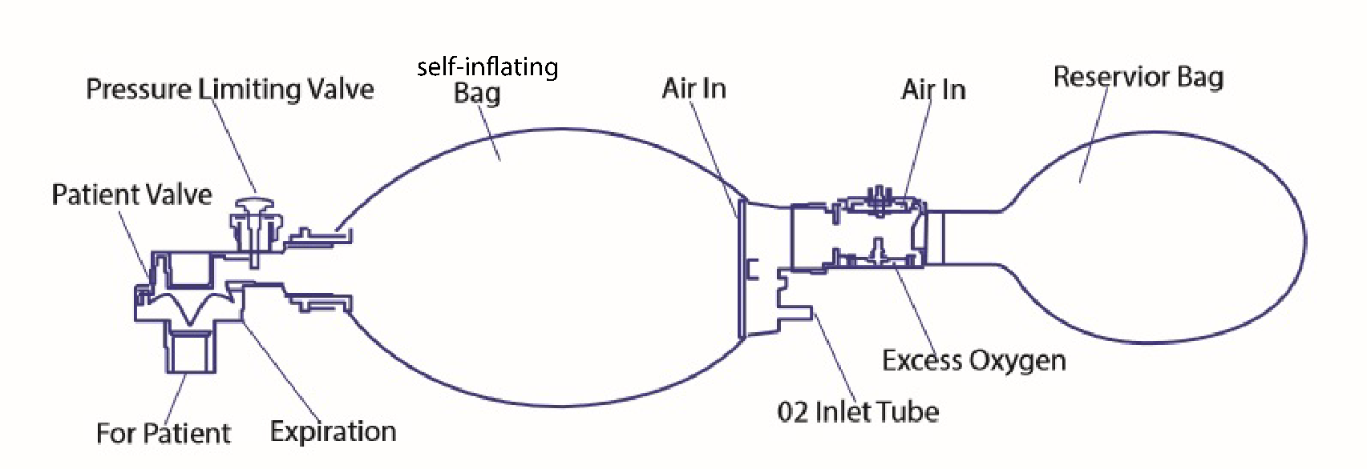

**Figure 4: Diagram of parts. Adapted from diagram by Academy of Medical and Dental Anesthesia. (https://admatraining.org/wp-content/uploads/2017/11/11-3-B.jpg)**

**Valve system A**

The patient and pressure limiting valves are optimized to prevent backflow of exhaled air into the bag as well as over-pressurization of the lungs during inhalation. The 3D printing of these parts may be advantageous over other fabrication methods, as the production facilities can be distributed across a broad range of locations. In addition, the average temperature range and low elasticity of the parts allows them to be made of common food-grade 3D printing filaments such as polyethylene terephthalate (PET) or polyethylene trimethylene terephthalate (PETT). However, the use of common non-food grade 3D printing filaments such as polylactic acid (PVA) or acrylon butadiene styrene (ABS) could pose a risk to the patient since these materials can store bacteria and potentially toxic to the human body (2).

*Pressure-limiting valve*

The pressure limiting valve is a basic safety valve which comprises of an outer casing, an inner plunger, and a spring. While the casing and plunger can either be 3D printed or injection molded, the spring cannot be 3D printed and must be sized correctly so that the valve blows off at no more than 40 cmH2O.

*Patient valve*

The patient valve is a one way valve designed to allow the flow of oxygen during inhalation and release of exhaled gases. It comprises of an outer shell with inlet and outlet passages as well as an inner diaphragm. These parts are also capable of being 3D-printed or injection molded, and no spring is required since the flow of gases one way versus the other can either push teh diaphragm open or closed to reveal the inlet and outlet passages.

**Bag (self-inflating)**

On the other hand, 3D printing may not be practical for the production of the bag (and mouthpiece, if applicable). The self-inflating capability of the bag means that it must be made of a material that has a high amount of elasticity while also having a certain amount of rigidness. These types of elastic semi-rigid containers are commonly made from low-density polyethylene (LDPE), *which has not been commercially adapted for 3D printing*. The reason for this is due to LDPE having weak layer bonding at printing temperatures as well as a very high shrinkage rate which results in the warping of the part during 3D printing (3).

The most common and established method for the production of low-density polyethylene is **injection molding** (4). This involves injecting molten plastic into a metal mold at a high rate before allowing the part to cool. The setup cost of this method is higher than that of 3D printing, but allows for faster mass production of LDPE components. **Where a 3D printer might be capable of producing a dozen units per day, an injection molding plant can produce hundreds of units in the same amount of time.** The expediency of production is critical towards meeting the demands of this sort of crisis.

**Valve System B**

The other valve comprises of the inlet tube fitting and flexible reservoir bag fitting. Depending on the setting, it can be configured to supply pure oxygen or outside air. As with the patient valve, it allows for the inflow of gases into the bag chamber from the reservoir and/or inlet tube, but a diaphragm prevents the backflow of gases during compression of the bag. It also comprises of a diaphragm and outside casing with compression fittings for both the tube and reservoir. It can also be either 3D-printed or injection molded.

**Reservoir bag**

The reservoir bag can be manufactured from either thinner LDPE or utilize common food-grade bags which fit the size requirements. The important functions of the bag are that it be able to be attached and sealed to its connection with the main bag while not having any perforations. If connected to an auxiliary oxygen supply in a hospital setting, the bag connection must be able to adjust to fit such connections. Thus, the production of adapter pieces can be performed through injection molding or 3D printing since the adapters would fall into the same material category as the patient and pressure limiting valves.

Flow-inflating bag valve masks are less commonly used in this function and are more commonly used for anesthesiology (5). However, the external oxygen supply pressurization of this type means that the bag can be made from thinner LDPE or more common food-grade bags since the elasticity requirements are different. This type of mask must have an external pressurized oxygen supply which may not be accessible or available depending on the patient settings and hospital resources in a crisis.

IV. Closing Remarks and Outline of Needed Resources

We have proposed collective, serious consideration of the use of bag-valve ventilators, operated manually by heroic volunteers, to save patients in the COVID-19 epidemic. Bag-valve ventilation is commonly used in emergencies, and is a maximally simple type of ventilator. The use of long-term bag-valve respiration in a crisis has been successful before in significantly decreasing fatality among polio patients during, for example the ventilator shortage of the 1952 Copenhagen polio epidemic. It is not yet clear whether this method could be a viable lifesaving measure for this inherently different disease. However, it is inevitable that patients will be turned away from hospitals with no means of support whatsoever. Medical professionals in particular, who have the greatest understanding of the nuances of treating this disease, are the people who must make a call on whether this option is worthwhile.

Among many medical professionals, a likely reaction to this proposal will be that long-term bag-valve ventilation, especially by a possible civilian with no medical experience who has had a brief training, represents an abysmal standard of care, with risk of real injury to the the patient. This is undeniably true**. However, the successful precedent of this method in the 1952 Copenhagen polio epidemic, and the widespread overall use of bag-valve masks in emergency situations, suggests we *must* acknowledge this option as a potential lifesaving means of offering ventilation during this crisis**. It is up to medical professionals to ascertain whether this use of manual bagging would be ethically preferable to turning patients away at the hospital. However, due to the maximal simplicity of this method, it is also their duty to seriously consider it as a possible option.

Outline of needed resources for this initiative:

* **Human resources and associated equipment:** 
  + People recruited to manually operate the ventilators.
  + Expert medical staff to determine efficacy of method.
  + Administrative staff to remotely oversee recruitment, assignment, and operations.
  + Trained medical staff to oversee ventilation and patient care care.
* **Containment resources:** 
  + Stadiums or other areas separated from society, with nearby housing for staff, and supplies of food/water/morale boosters/adequate hygiene and menstrual products/other necessities.
  + Determination of whether acquired immunity to the virus exists in recovered individuals. **Immunological tests to monitor for continued presence of antibodies in immune human operators. *Note: large degree of ethical concern**
  + **Proper hazmat-style PPE, gloveboxes, or other adequate containment, if non-immune or questionably immune operators are used.** **\*Note: Large degree of ethical concern**
* **Ventilators:**
  + Valve system A
  + Self-inflating bag
  + Valve system B
  + Reservoir bag
* **Auxiliary supplies:**
  + Tracheostomy tubes and tracheostomy equipment
  + Sealing ventilator face masks, and enough razors to shave facial hair of bearded individuals daily—if face masks are used
  + Oxygen,
  + Tubes for supplemental oxygen
  + Beds/general medical equipment
  + Transport equipment

**In the rush to build respirators ASAP, we hope that pointing out this maximally simple solution might save at least one life. Even if bag-valves do not turn out to be a viable lifesaving method, we must ensure this option is seriously considered by many people in an organized and possibly effective manner, and we must consider recruiting volunteers NOW.**

We would like to acknowledge Emma Stavropoulos for finding the example of the Copenhagen polio epidemic as an existing use for this proposed method, and suggesting the use of large spaces such as stadiums to isolate patients from the rest of society. We also thank Christos D Samolis for useful discussions. We additionally thank Sam Trumbo and Mike Brown for insightful discussions about the current understanding of immunity and the possible importance immune individuals could have in fighting the virus.

**NOTICE \*\*\*\*\*\*\*\*\*\*\*\*\*\*\*\*\*\*\*\*\*\*\*\*\*\*\*\*\*\*\*\*\*\*\*\*\*\*\*\*\*\*\*\*\*\*\*\*\*\*\*\*\*\*\*\*\*\*\*\***

**\*\*\*\*\*\*\*\*\*\*\*\*\*\*\*\*\*\*\*\*\*\*\*\*\*\*\*\*\*\*\*\*\*\*\*\*\*\*\*\*\*\*\*\*\*\*\*\*\*\*\*\*\*\*\*\*\*\*\*\*\*\*\*\*\*\*\*\*\*\*\*\***

**Neither author of this document has a formal background in bioethics or medicine, and we must leave these decisions to those who do. We apologize if any of our suggestions on this ethically delicate topic risk putting any person unnecessarily in harm’s way, more than they already would be during this extreme crisis.**

**\*\*\*\*\*\*\*\*\*\*\*\*\*\*\*\*\*\*\*\*\*\*\*\*\*\*\*\*\*\*\*\*\*\*\*\*\*\*\*\*\*\*\*\*\*\*\*\*\*\*\*\*\*\*\*\*\*\*\*\*\*\*\*\*\*\*\*\*\*\*\*\*\*\*\*\*\*\*\*\*\*\*\*\*\*\*\*\*\*\*\*\*\*\*\*\*\*\*\*\*\*\*\*\*\*\*\*\*\*\*\*\*\*\*\*\*\*\*\*\*\*\*\*\*\*\*\*\*\*\*\*\*\*\*\*\*\*\*\*\*\*\*\*\***

References

1. *Academy of Medical and Dental Anesthesia. (n.d.) Bag Valve Mask Diagram [image]. Retrieved from https://admatraining.org/wp-content/uploads/2017/11/11-3-B.jpg*
2. *Conn R., Kolstad J, Borzelleca J, Dixler D, Filer L, Ladu B, Pariza M (2 April 1995). “Safety assessment of polylactide (PLA) for use as a food-contact polymer”. Food and Chemical Toxicology. 33 (4): 273-283*
3. *Olesik P, Godzierz M, Koziol M (8 August 2019).*

*“Preliminary Characterization of Novel LDPE-Based Wear-Resistant Composite Suitable for FDM 3D Printing” Materials. 12 (16): 2520*

1. *Kalpakjian S, Schmid S (2014). Manufacturing and Engineering Technology (7th ed., pp. 502-508). Upper Saddle River, NJ: Pearson.*
2. *Anitha GF, Velmurugan L, Sangareddi S, Nedunchelian K, Selvaraj V (1 August 2016). "Effectiveness of flow inflating device in providing Continuous Positive Airway Pressure for critically ill children in limited-resource settings: A prospective observational study". Indian Journal of Critical Care Medicine. 20 (8): 441–447.*
3. *Thevarajan et al. (2020), Breadth of concomitant immune responses prior to patient recovery: a case report of non-severe COVID-19. Nature Medicine.*
4. *Channappanavar, Zhao, Perlman. (2015) T-cell-mediated immune response to respiratory coronaviruses. Immunol Res. Author manuscript.*
5. *Greenfieldboyce, NPR “Goats and Soda” Article, “Do You Get Immunity After Recovering From a Case of Coronavirus? March 20, 2020.*
6. *West, J.B. (2005). The physiological challenges of the 1952 Copenhagen poliomyelitis epidemic and a renaissance in clinical respiratory physiology. J. Appl. Physiol, author manuscript.*

1. Technically, CPR is actually the simplest possible respirator, as the compressions ideally move air in and out of the lungs. But it would almost certainly be far too traumatic for the patient to use this method for weeks on end. At the same time, iron lungs, which are akin to CPR, in which pressure variations (in this case, in a sealed chamber around a person’s torso) promote breathing, are a type of option also worth seriously considering, particularly if they can house multiple people. That will take longer to design and produce, though.
2. It is also worth pointing out that face masks require that any facial hair be regularly shaved to be as short as possible, which would require many razors.